St. Matthew’s Primary School - Nursery



Nursery Information for Parents


2025- 2026

Welcome to our Nursery

Dear Parents and Carers,

This booklet has been written to give you some information about our Nursery so that you and your child can get the most out of your time with us. We are aware that there is a lot of new information for you to absorb; you should find everything you need in this pack. If you require any further information, then please do not hesitate to contact us.

In our Nursery we aim to help the children develop physically, emotionally, socially, intellectually and creatively. We believe that the main way in which children grow in these areas is through play and so we aim to provide an environment that encourages children in their play, encourages independence and facilitates their learning.

We really want the time that your child spends with us to be a positive, stimulating and enjoyable experience. We aim for them to grow in confidence and independence as they begin to learn new skills and develop socially and emotionally.

Communication
We can provide the best Nursery experience for your child if there is good communication between home and school. Please talk to your child’s Key Worker at the start of your child’s session if there is anything you feel they would benefit from knowing. Alternatively, if you are unable to speak to your child’s Key Worker, please email to the school office and they will send it your child’s Key Worker.

Session Times:

Morning session | 8:45 am – 11:45 am
Lunchtime | 11:30 am - 12:15 pm
Afternoon session | 12:15 pm – 3:15 pm

About our Nursery

Lunchtime
The children eat lunch from 11:30 am-12:15pm. If your child is joining us for the lunchtime session please bring them to the Nursery gate at 11:30am and they must bring in a packed lunch from home. If you have opted for your child to stay at school for lunchtime and bring in a packed lunch, there will be a charge of £3 per day payable to help cover staffing costs. Please be aware that this is payable even if your child is absent. This must be paid termly on receipt of your invoice. Information on how to pay is on the bottom of the invoice. Unfortunately, we are unable to provide a hot meal option for children attending Nursery.

Attendance:
The school is keen to encourage the habits of good attendance and good punctuality right from when the children start in Nursery. Please endeavour to bring and collect your child on time. Children who arrive after the start of the session often find it harder to settle. Likewise, at the end of the session it is important that children are collected on time so that they don’t become anxious when the other children have left. If the gate to Nursery is closed please report to the office to sign your child in.

It is important that you let your child’s Key Worker or the school office know if there are any changes to your collection arrangements. We will not hand over children to adults unless we have been informed of who they are going home with. Furthermore, if your child is absent please inform the school as soon as possible. You can contact the school on:

Contact Details:

St Matthew’s Primary School 19 Norfolk Street, Cambridge CB1 2LD Telephone: 01223 568838
Fax: 01223 568839
E-mail: office@stmatthews.cambs.sch.uk

- Key Workers
Once your child has been given a place in our Nursery we will assign them to a Key Worker. The role of the Key Worker is to build up a safe and secure relationship with your child to ensure that they can develop both socially and academically in our Nursery. If you have any concerns about your child please speak to your child’s Key Worker. It is often possible to see them very briefly at the beginning or end of the Nursery session but do make an appointment to be sure that they are available if you need more than a few minutes.

All Key Workers plan together. The planning is based on ‘Development Matters in the Early Years Foundation Stage.’ This document underpins all the learning that occurs in our Nursery by supporting, fostering, promoting and developing children's development in all areas of learning but with a key focus on the Prime Areas. These are explained in more detail later in the booklet.

Session Content

During the sessions the children have access to a variety of learning opportunities encompassing The Early Years Foundation Stage Curriculum through first hand and direct experiences. The Nursery operates a 'free flow' system with the children. The children select from carefully structured independent and adult led activities both indoors and in our garden. The children are encouraged to move purposefully and freely between these areas and they also have access to our bicycle track.
During the session, the children participate in a Key Worker circle time. This is when they gather together to sing, have a story, play maths or language games or discuss something related to our developing interests. At the end of each session children help to tidy up and then join together as a whole class for a range of activities including singing, finger rhymes and stories to finish the session.

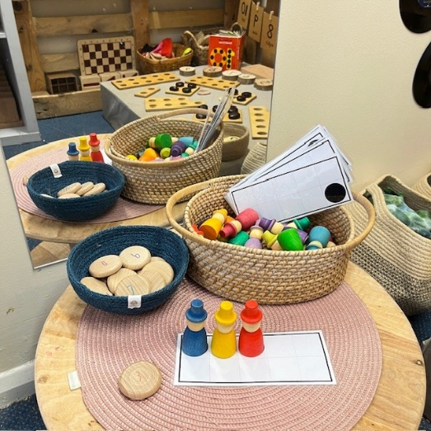

Settling in

Home Visit or Classroom Visit

This is a chance for you and your child to meet with their Key Worker and the class teacher in the Nursery or at your home. The visit will last for approximately 15- 20 minutes and provides an opportunity for you and your child to ask any questions. Furthermore, it is a great opportunity for us to get to know your child on an individual basis. The visits are optional but highly encouraged. We will send out an invitation to these later in the summer term. If you have any questions please get in contact via the school office.

‘All About Me’ book:

Your child will be given an ‘All About Me’ book. This is an important book that we ask parents/carers to fill in. The information you provide will help us ensure that we are supporting your child at Nursery. Please fill this in and return it to your child’s Key Worker either at the individual visits or once your child has started in Nursery.

Your child’s first session:

Our Nursery class is your child’s introduction to school life so we really want to make their start as smooth as possible. On their first day, children stay for just one hour, please ensure that you are able to be contacted by the school in the event of your child becoming unsettled during the session.
If both you and your child’s Key Worker feel that your child has settled well during their first session, they are allowed to start their following session full time on their own. However, every child is unique and it may take some children longer to settle at Nursery. If this happens, your child will be invited for another one hour visit and then the sessions will be gradually increased. Our transition process is flexible to suit the needs of your child. If you have any concerns or queries about your child settling in please talk to your child’s Key Worker.

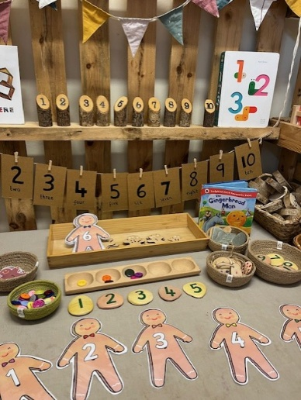

Contact Details and Medical Information:
Please ensure that you have completed the contact details for your child and returned them to the school office as soon as possible. If any contact information changes throughout the year please ensure that you update the office immediately.
If your child has any medical requirements that we need to be aware of please make sure you have discussed these with your child’s Key Worker as well writing all the relevant information on the contact forms.
We prefer not to administer prescribed medicines to children in Nursery. However, if it is essential, please inform your child’s Key Worker and the school office who will give you a permission form to sign. Prescribed medicines will only be administered by nominated staff. The nominated staff will supervise the taking of medicine, when possible, provided that:
    - the medicine has been prescribed by a doctor
    - full written instructions are enclosed with the medicine
    - the medicine is clearly labelled with the child’s name.
All tablets and medicines must be handed in at the school office and will be kept there.

The only sure way of guaranteeing that medicine is administered is for parents to come into Nursery and give it to the child themselves. The school will make its best effort but cannot be held responsible if medicines are not administered.

- Illness and Absence:
If your child is absent from Nursery, please send a brief note to explain the absence, telephone the school office (01223 568838) or send an email as soon as possible office@stmatthews.cambs.sch.uk
If you are wishing to take your child out of Nursery during term, an application must be made in advance. Please collect the form from the office. Please note, if your child joins the Reception class, St Matthew’s School will not grant leave of absence during term-time unless there is an exceptional circumstance.

Returning to Nursery after Illness:
Please do not send your child back to Nursery until they are fit and well. Too often we see children return too early and then they suffer a relapse. Children who have been vomiting or have had diarrhoea should not return to Nursery until they are completely better. The chance of them passing the infection on to other children is extremely high. They should stay off Nursery for 48 hours after the symptoms have cleared up and are well enough to attend school.

St. Matthew’s Nursery

Supporting your child at Nursery

What will my child need at Nursery?

- Clothes - Please don’t dress your child in their best clothes - Nursery can get messy! We particularly enjoy gardening, painting and spending time in our mud kitchen.

- Easy to fasten clothes - Please be sure that your child is dressed in clothes that allow him or her to be independent both indoors and outdoors. We want the children to be as independent as possible so please think carefully about buckles, buttons and laces.

- Clearly Labelled Clothes – Please clearly name all items of clothing, including hats, scarves and gloves.
- Spare Clothes – Please leave a spare pair of clothes on your child’s peg. We do have spare clothes should an accident happen at Nursery. However, it is easier if the children have spare clothes on their peg. If your child does borrow any of the Nursery clothes please wash them and send them back in as soon as possible.
- Water bottles – Your child should bring a water bottle into Nursery. Please ensure this is clearly named and place in the water bottle box. Juice and squash are not permitted in their water bottles, although it is fine to have juice in their lunch boxes.

- Toilet Training – If your child is not yet fully toilet trained please speak to your child’s Key Worker. We can support both you and your child with this. If your child is using pull-ups/ nappies, please send in a pack which we can use at Nursery.

- Wellington Boots and Rain Coats/Waterproof all-in-ones - Outdoors is an extension of the indoor classroom and will be accessed on a daily basis by the children in all weathers. Please ensure that they have a pair of named wellington boots and ideally a full set of waterproof clothing to store at Nursery. It would be beneficial if you could leave them at Nursery as we cannot predict the weather. However, please feel free to take them home when they are needed.

- Punctuality & Communication - Please inform us if someone other than the regular parent/carer is coming to collect the child. We will not allow them to leave with someone we don’t know or haven’t been told about. Your child must always be brought and collected by an adult. Please collect your child and drop them off on time.



St. Matthew’s Nursery

Key Nursery Information

Love of Books: From the moment your child starts in our Nursery s/he will be encouraged to develop a love of books. The staff plan for the development of your child’s spoken language in many ways – through drama, singing, telling stories and rhymes. There is a selection of books available from the Nursery which your child may borrow. Once you have shared the books with your child, it will be up to you and your child to change the books to read at home.

Children’s Work: The children are encouraged to place their artwork into their individual trays until the end of each session. The children will then be encouraged to check through this tray so they can take their work home.

Book bags: These are given to your child when they start in Nursery. You can use them to put any books you may have borrowed.

Fruit and milk: The children have access to free fruit and milk at snack time. Please feel free to send your child in with a water bottle and a fruit pot.

Sun protection: On sunny days, particularly at the start and end of the school year, please put sun cream on your child and send in a hat to wear outside. Please ensure that all clothing is named.
Please note that we cannot put sun cream on your child unless we have been given written permission.

Birthdays and Celebrations: We love to celebrate special occasions in Nursery. If you wish to send in something we would appreciate individual buns or cakes that can be easily cut up rather than sweets. We hope you will be able to share the celebrations with us.

Contact Information: Please ensure that the school office has your child’s up to date contact information. This includes all telephone numbers and any medical conditions or allergies that your child may have. If your child needs any medication to be administered you will need to provide us with a protocol from your GP and medication for the medical condition. We will also need you to sign a consent form which you can get from the school office.

Contributing to Learning Journeys: We love to include family contributions to the children’s learning journeys throughout their time with us. This could be many things, for example: special events and celebrations that are important to your family, important milestones for your child, progress they make at home with a skill, holidays, new skills etc. We encourage families to bring in photos and written comments or to email these to the class teacher.

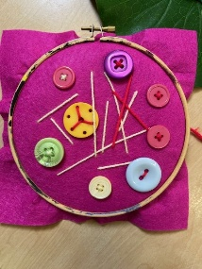

Nursery Curriculum
We aim to provide a broad, balanced, stimulating and supportive environment in which each child can grow and develop. One of our goals for the children is to help them become as independent as possible. This means giving them lots of opportunities to make choices, including freedom to access the resources they would like and the freedom to play inside and outside.

We follow the Early Years Foundation Stage Curriculum which is very holistic. It has seven areas of learning and we plan our activities carefully in order to meet the needs of children within this framework. There are three ‘Prime Areas’ and four ‘Specific Areas’. The Prime Areas focus on the relationships, experiences, communication and the children’s physical development. These are the foundations for children’s development. These then run through and support the learning in the Specific Areas. The Specific Areas focus on supporting the children’s development, skills and knowledge. The areas of learning are as follows:

Prime Areas

 Personal, Social and Emotional Development
This area covers Self Regulation, Managing Self and Building Relationships -
- Building self confidence and self esteem
- Making relationships, developing a sense of community and learning how to function in a group outside of their family
- Developing behaviour and self control and increasing independence

 Communication and Language
This area covers Listening and Attention & Speaking
- We learn to communicate with others in a range of ways by listening to others and taking turns speaking.
- We develop a wider vocabulary and descriptive language
- We learn to listen attentively to stories, songs and rhymes and respond to what we hear
- We learn to follow instructions and answer questions
- We learn to communicate our own ideas and stories

 Physical Development
This area covers Gross and Fine Motor Skills
- We enjoy climbing outside on the apparatus and during our weekly movement session
- We use PE equipment like hoops, balls and beanbags to play games
- We develop our fine motor skills by learning to tear, cut, sew, and manipulate objects
- We handle tools and equipment effectively, including pencils and pens, cooking utensils and gardening equipment
- We learn the importance of physical exercise and a healthy diet and talk about ways to keep healthy and safe
- We learn to manage our own basic hygiene and personal needs successfully, including dressing and going to the toilet independently
Young children's physical development is inseparable from all other aspects of development because they learn through being active and interactive.

St. Matthew’s Nursery

Specific Areas

 Literacy
This area covers Comprehension, Word Reading and Writing

We help children take the first steps towards reading and writing. We aim to foster an enjoyment of books by sharing them with the children and making them readily available, as well as making other examples of writing available in the classroom, such as labels, signs and lists. We give children opportunity to “write” using lines, symbols, pictures and letters in such contexts as the home corner and the playground. The children will also take part in a daily phonics session. At St Matthew’s we follow a scheme called Monster Phonics. These sessions help develop the children’s speaking and listening skills. They become attuned to the sounds and begin to develop oral blending and segmenting skills which lay the foundations for teaching of systematic synthetic phonics for when they start Reception.

 Mathematics
This area covers Number and Numerical Patterns
This area covers helping the children to grow in confidence and competence in using key skills in maths. This includes counting, sorting, matching, seeking patterns, making connections, recognising relationships and working with numbers, shapes, space and measures. This comes through stories, songs, games and imaginative play, so that children can enjoy using and experimenting with numbers.

 Understanding the World
This area covers the Past and Present, People, Culture and Communities
In this area of learning children are developing the crucial knowledge, skills and understanding that help them to make sense of the world. This includes helping children develop the skills of observing, predicting, exploring, investigating, interpreting, discussing, decision-making and using tools and materials appropriately. Through this they learn about themselves, other people and the broader world around them. It provides a foundation for historical, geographical, scientific and technological learning.

 Expressive Arts and Design
This area covers Creating with Materials, Being Imaginative and Expressive
This focuses on the development of children’s imagination and their ability to communicate and express ideas and feelings in creative ways through art, woodwork, clay, sewing, music and movement. We use paint, dough, singing, material and many other media to give the children opportunity to develop creatively.

Creative development is fundamental to successful learning. Being creative enables children to make connections between one area of learning and another and so extend their understanding. This area of learning includes art, music, dance, role-play and imaginative play.

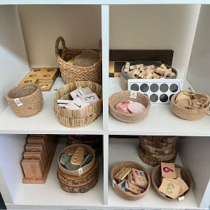

St. Matthew’s Nursery

What if my child needs extra support at Nursery?

We have lots of support on offer for your child to both help them with their learning and also any social or emotional support they may need throughout their time in our Nursery. Some of the support on offer is outlined below:
- If you have any concerns about your child, please speak to your child’s Key Worker and/or class teacher. The schools SENDCo (Special Educational Needs Co-ordinator) is Christina Bates.
- If your child is struggling to manage their feelings or having social difficulties either in Nursery or at home, please talk to your child’s Key Worker who can put you in contact with the Early Intervention Family Worker.
- If you are worried/have concerns about your child’s Speech and Language please ask your child’s Key Worker for details about the Speech and Language Drop in clinic.

- Alternatively, you can still contact your Health Visitor if you have any concerns.

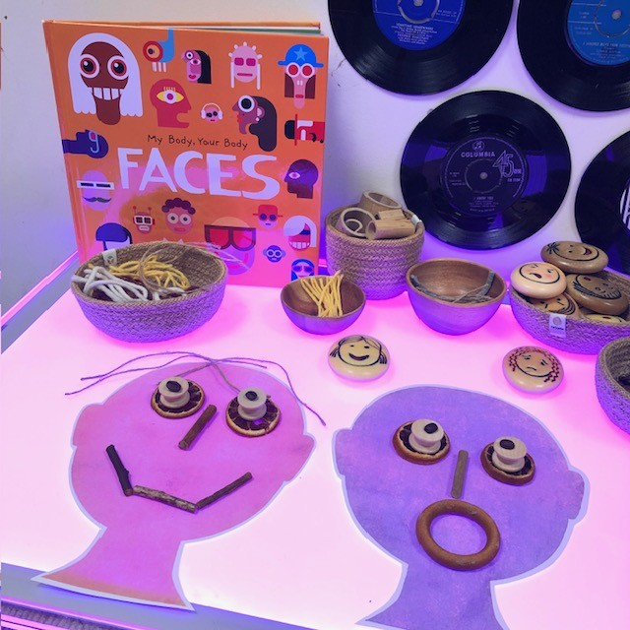

Ways you can help at home

Things you can do before your child starts Nursery:
- It is a good idea to allow other family or friends look after your child so that they get used to having time away from you.
- Be open and honest with your child and talk to them about where they are going, what they might do and who is picking them up.
- Please inform us before the beginning of term what your child likes to be called to ensure that we can label their storage trays and pegs correctly.
- Fill out all the contact information forms and hand them back to the office including all medical information as soon as possible.
- If your child has not had one, take them for an eye test and hearing test.

- Talk positively about Nursery to your child.

- Encourage independence - We are there to support your child with toileting, however it is a good idea to encourage your child to try and do things independently, for example you might want to ask your child to have a go at taking their trousers down on their own before they go to the toilet.


St Matthew’s Nursery

The Importance of Play

Play is a child’s way of learning. It is the most natural way in which children make sense of the world around them, develop their skills and understanding and make sense of themselves and others.

During each session your child will have opportunities to play with sand, water, home corner, small world toys, malleable materials such as clay and dough, loose parts, block play, paint, scissors and glue. Imaginative role-play, music, movement and dance are also highly valued nursery activities. Sometimes the children play on their own, sometimes alongside other children and at other times with their friends.

Play gives children opportunity to learn through first hand experiences, for example to discover capacity through pouring liquid from jug to jug in the water tray. They can explore their environment, be creative and experiment to see how things work.

It is vital that children have chance to direct their own play, without constant guidance from adults. We need to give them time and space to immerse themselves in their play, whether it is quiet and reflective play or more boisterous and energetic.

Our role as adults is to provide an environment that stimulates children’s play and to give your child the opportunity to explore and talk about what they are doing. We must support and scaffold their play. We can do this by observing and recognising what the child is attempting to do in their play and interact to help them progress by suggesting, commenting, questioning and playing with the child.

“Play that is well planned and pleasurable helps children to think, to increase their understanding and to improve their language competence. It allows children to be creative, to explore and to test their own conclusions.”
HMI - “The Education of Children Under Five”

We do hope that you have found this booklet useful.

If you have any other queries or questions then please do not hesitate to come and talk to us.

The Nursery Team

