Safeguarding your children online

Dear Parents/Carers
Online safety of children is becoming a growing issue, and ever evolving.
I wanted to share some useful links and resources, and these will also be added onto the website, should you ever need them.
NSPCC:
We wanted to let you know about our brand-new online safety guide. NEW! Launched this week for Safer Internet Day: The NSPCC has partnered with Vodafone to develop an online safety guide for parents and carers of children under 5. The guide contains useful information about common risks this age group face, some guidance around screen time limits and lots of practical tips for families:
NSPCC Link to Keeping Children Under 5 Safe online
CEOP:
You can report online abuse to CEOP;
‘We are here to help and give you advice, and you can make a report directly to us if you are worried about online sexual abuse or something has happened to your child online which has made either you or your child feel unsafe, scared or worried. This might be from someone they know in real life, or someone they have only ever met online.’
This link to their website is: https://www.ceop.police.uk/Safety-Centre/How-can-CEOP-help-me-YP/How-can-CEOP-help-me-parent/
The website also has lots of resources you can sue with your children’
4-7: https://www.ceopeducation.co.uk/4_7/
8-10: https://www.ceopeducation.co.uk/8_10/
There are also useful guides for parents on many different aspects of online safety, such as:
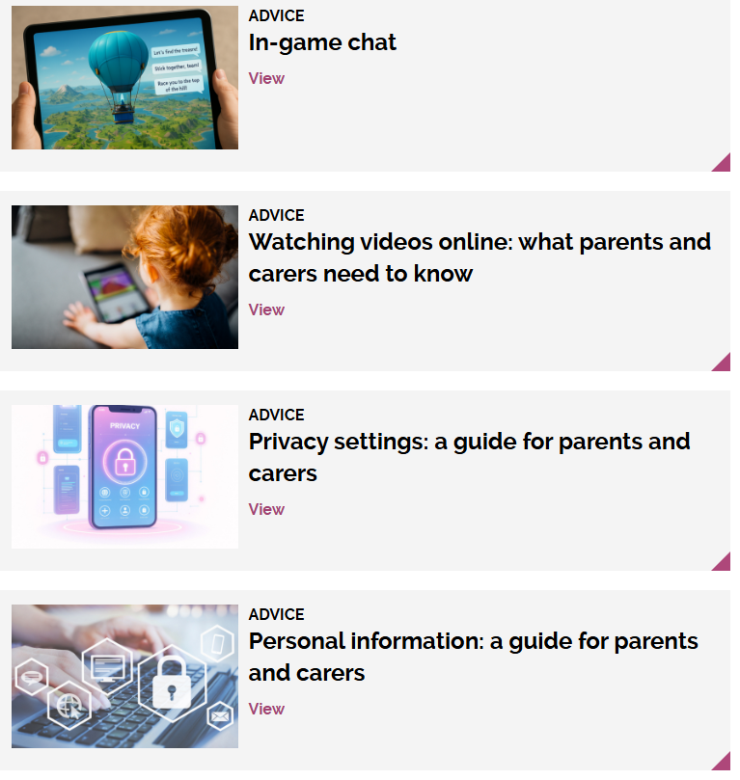
CEOP Link - Advice to Parents/Carers

Internet Matters:
https://www.internetmatters.org/
This website has lots of advice on how to keep your children safe online.
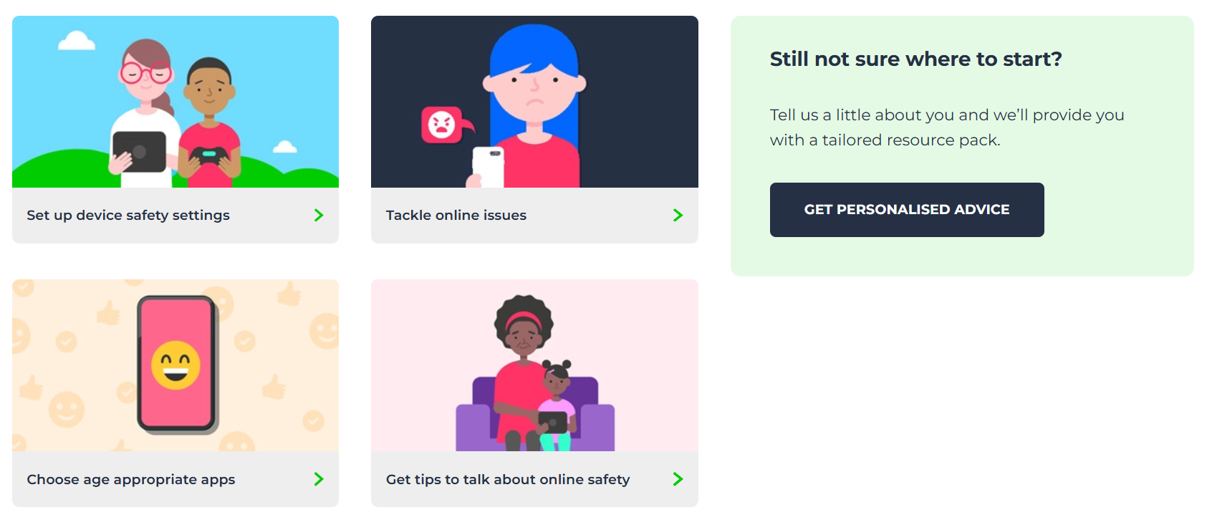

Childnet:
This website has a useful leaflets for [parents, which also come in a range of languages:
https://www.childnet.com/resources/supporting-young-people-online/
Available in English, Arabic, Bengali, Farsi, French, Hindi, Polish, Punjabi, Somali, Spanish, Urdu, Turkish, Vietnamese, Welsh.
UK Safer Internet Centre
https://saferinternet.org.uk/guide-and-resource/parents-and-carers
This provides a range of information on devices your child might use:

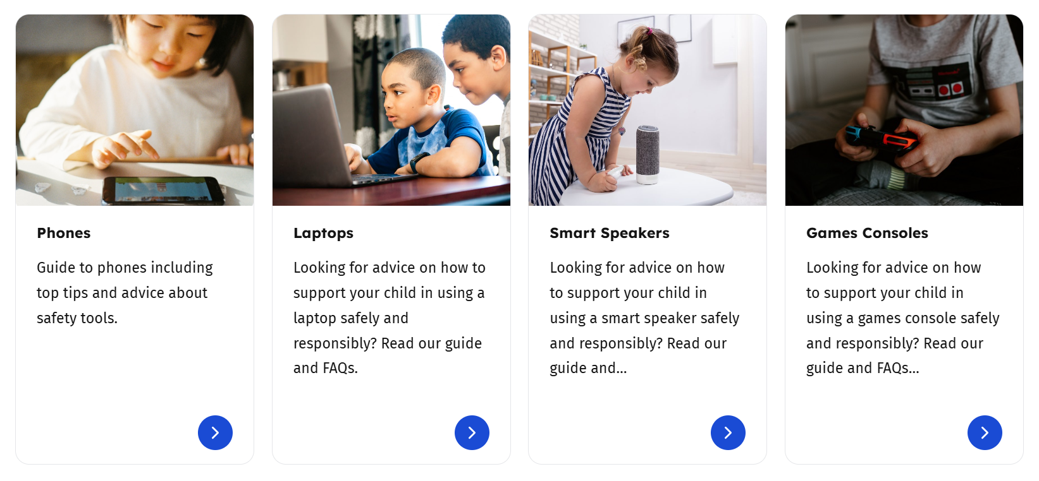
The site also has a texting and slang dictionary:
https://www.internetmatters.org/resources/text-dictionary/
We’ve compiled a list of text language terms to help you decipher any text slang you might not understand. Learn about the words your child might use to communicate with their friends on social media, in video games and through text messaging.
And an Internet safety glossary where you can learn about digital terminology, apps and more;
https://www.internetmatters.org/resources/glossary/

TeacherActive:
This site has a clear guide to the meaning of emoji’s as well as information about the ‘manosphere’ and Incel culture
https://www.teacheractive.com/media-post/decoding-emojis-a-guide-for-teachers-and-parents

Smart Phone Free Childhood
Smartphone Free Childhood is a grassroots movement bringing families together to stand up for healthier, happier childhoods. We already have a number of parents who have signed up to the Parent Pact, agreeing to delay giving their child a smartphone until they are 14 years of age.
We will sending through more information very soon on an upcoming talk we will be hosting just after Easter.
https://www.smartphonefreechildhood.org/

