https://www.youtube.com/watch?v=EyrEOp660tU

"Chirpy Chirpy Cheep Cheep"
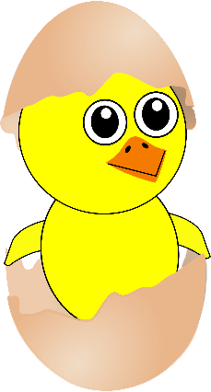
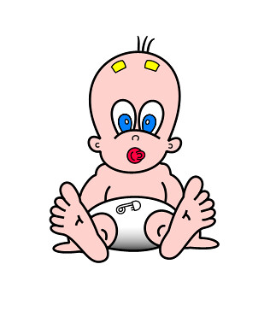
Where's your mama gone? (Where's your mama gone?)
Little baby Don (Little Baby Don)
Where's your mama gone? (Where's your mama gone?)
Far, far away
Where's your papa gone? (Where's your papa gone?)
Little baby Don (Little baby Don)
Where's your papa gone? (Where's your papa gone?)
Far, far away
Far, far away
Last night, I heard my mama singing a song
Ooh-We, Chirpy, Chirpy, Cheep, Cheep
Woke up this morning and my mama was gone
Ooh-We, Chirpy, Chirpy, Cheep, Cheep
Chirpy, Chirpy, Cheep, Cheep, Chirp
Where's your mama gone? (Where's your mama gone?)
Little baby Don (Little Baby Don)
Where's your mama gone? (Where's your mama gone?)
Far, far away
Where's your papa gone? (Where's your papa gone?)
Little baby Don (Little baby Don)
Where's your papa gone? (Where's your papa gone?)
Far, far away
Far, far away
Last night, I heard my mama singing a song
Ooh-We, Chirpy, Chirpy, Cheep, Cheep
Woke up this morning and my mama was gone
Ooh-We, Chirpy, Chirpy, Cheep, Cheep
Chirpy, Chirpy, Cheep, Cheep, Chirp
Let's go now
Last night, I heard my mama singing a song
Ooh-We, Chirpy, Chirpy, Cheep, Cheep
Woke up this morning and my mama was gone
Ooh-We, Chirpy, Chirpy, Cheep, Cheep
Chirpy, Chirpy, Cheep, Cheep, Chirp
Altogether now
Last night, I heard my mama singing a song
Ooh-We, Chirpy, Chirpy, Cheep, Cheep
Woke up this morning and my mama was gone
Ooh-We, Chirpy, Chirpy, Cheep, Cheep
Chirpy, Chirpy, Cheep, Cheep, Chirp
One more time now
Last night, I heard my mama singing a song
Ooh-We, Chirpy, Chirpy, Cheep, Cheep
Woke up this morning and my mama was gone
Ooh-We, Chirpy, Chirpy, Cheep, Cheep
Chirpy, Chirpy, Cheep, Cheep, Chirp
Let me all sing it now
Last night, I heard my mama singing a song
Ooh-We, Chirpy, Chirpy, Cheep, Cheep
Woke up this morning and my mama was gone'

