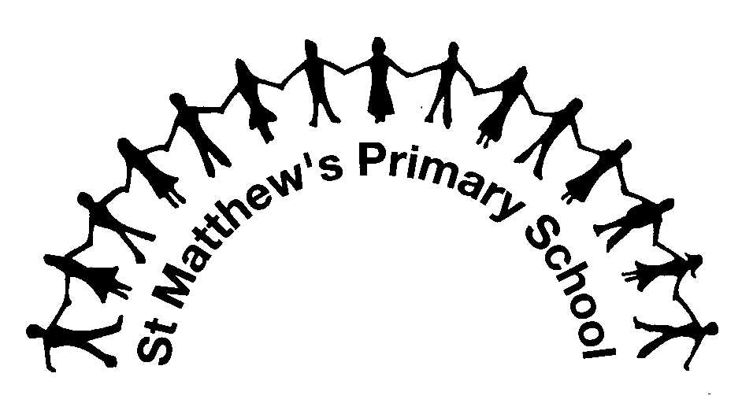

Communication between School and Home
We believe we are partners in your child’s education. The foundation of every partnership is good communication. This document outlines how the school and children’s parents and carers can communicate with each other to make this partnership strong for the benefit of all of the children at the school.
Emails, Messages and Letters
We use eSchools to send home all school letters and newsletters.
You can also use the eSchools Messaging Service to email a class teacher. Please remember:
- A class teacher will send a response, even if it is only an acknowledgement, within three working days of you sending an email.
- Remember a teacher is unlikely to read an email during the school day – they are teaching! Any urgent messages should be sent via the school office. You can use the school office email (office@stmatthews.cambs.sch.uk), but very urgent messages should be given to the office in person or by telephone in case an email is not picked up in time.
- If your child is unable to attend school, please contact the school office and NOT your child’s teacher.
- Remember, your child’s teacher’s time is valuable. Good communication supports the children’s learning and well-being. We do not want time that teachers spend working for the children - planning, assessing and marking - to be overrun with responding to emails, so please do not overuse the email system.
Who to Talk To
For most issues, your child’s class teacher is the first person to talk to.
You may also want to talk to the Assistant Head Teacher for your child’s age phase. The Assistant Head Teachers are:
- Kate Spencer-Allen – responsible for Nursery, Reception and Year One
- Annabelle Lewis – responsible for Years Two and Three
- Liz Steel – responsible for Years Four, Five and Six
The Head Teacher (Mr Davies) and the Assistant Head Teachers will often be in the playground or at the school gates at the beginning or end of the day. They are there so you can talk to them, ask them questions or raise any concern you may have. If you are not sure who to talk to, please ask and we will be happy to help.
When to Talk
There are organised consultation meetings as outlined below, but we know that sometimes we will need to communicate more urgently. Please tell us straight away if you have any issue or concern or need some more information to support your child.
- If a longer discussion is needed, it is usually best to make an appointment to meet (this can be done by emailing the teacher or other staff member using eschools, or through the school office).
- If it is a quick message, you can talk to the class teacher at the start of the day (but remember this can only be for a few seconds as the teacher needs to take the class in and do register). This may be enough time to arrange a later meeting or phone call.
- You can talk to the class teacher at the end of the day (the teacher may have more time at this point, though they may have another meeting already arranged)
- You can do this via email (using eSchools or through the school office).
Information about Your Child’s Curriculum
- Information about the curriculum can be found on the school website (www.stmatthews.eschools.co.uk).
- You can also log into eschools and visit your child’s class pages for curriculum information, latest spelling lists and other relevant info.
Information about Your Child’s Progress
- We have parent consultation meetings in the Autumn and Spring Terms.
- In the Summer Term you will receive your child’s Annual Report from their class teacher.
- If you have any concern or issue we want to hear about it straight away. If you wish to make another appointment with your child’s teacher please contact (see “Making an Appointment to See a Teacher” below).
- If a teacher has a concern about your child’s progress, they will also contact you to make an appointment.
Information About the School
Our school website is the best place to get information about the school. There you can find lots of information, including:
- The school diary
- Newsletters
- School results in statutory assessment tests and latest OFSTED reports
- Our School Development Plan showing our priorities for improving St Matthew’s
- Curriculum Information
- School Policies
- School Lunch Menus
- Information about how we spend our pupil premium and sport premium funding
- Information about provision for children with special educational needs and disabilities
Attendance Matters
- If your child cannot attend school, please let the school know by ringing or emailing the school office.
- If we do not hear from you, on the first day of absence the school will contact you as a matter of course to check that you are aware that your child is not in school.
- You can see your child’s attendance at school by logging onto eSchools.
- Where attendance or lateness becomes an issue (attendance less than 85%???) you will receive a letter from Mrs Lewis (Assistant Head with responsibility for attendance in school). If concerns are not resolved or are more serious still, our Education Welfare Officer will also be involved.
- Children should attend school whenever possible. The school can only authorise absence in exceptional circumstances and not for holidays. Should you wish to request an authorised absence, you can do so using the form that can be found on our website or from the school office. The form must be completed BEFORE the absence takes place for it to be considered.
Improving the School
- The school has a School Development Plan which sets out its priorities for improvement and actions to achieve them.
- All staff, parents and carers and children are involved in helping governors develop this plan.
- Parents are involved through parent questionnaires and also through “Meet the Head” events (see below).
Meet the Head
We hold regular “Meet the Head” events, roughly every half term.
These provide an opportunity for parents to ask the head teacher questions, raise issues or make suggestions about any whole school issues. (As they are public meetings, they are not for discussing concerns about individual children, staff etc). Governors also attend and host the meetings.
Sometimes the meetings have open agendas, sometimes they may have a particular theme or issue that has arisen from a previous “Meet the Head” or because the school wishes to consult on a new initiative or policy.
Light refreshments are available, younger children not at school are welcome. It is a great chance to meet people in the school community. The meetings are positive, lots of small (and sometimes larger) issues get sorted out and they have been invaluable in helping the school go from strength to strength.
Making a Complaint
We aim to resolve any problems or issues that come up as quickly as possible.
In the first instance you should talk to your child’s class teacher. If you are not satisfied or this does not seem appropriate, please talk to the Assistant Head Teacher for your child’s age phase (see “Assistant Head Teachers” above).
If you are still not satisfied, talk to the Head Teacher.
We would hope that by then your issue will be resolved. If not, you can make a formal complaint using the school complaints procedure. This can be found in the policies section of our website ro is available from the school office.
Please Keep Your Contact Information Up to Date
- If you don’t tell us about changes in your contact details, particularly email addresses or mobile phones, you might not receive important information from the school and we might not be able to contact you in an emergency.
- Please let the school office know about any changes to your contact information.

