Activity 1
Watch the film clip of The Lighthouse:
https://vimeo.com/21910518
MAKE SURE YOU HAVE A GROWNUP WITH YOU WHEN YOU GO ONLINE.
Then see if you can answer these questions. You could make notes of your answers on paper.
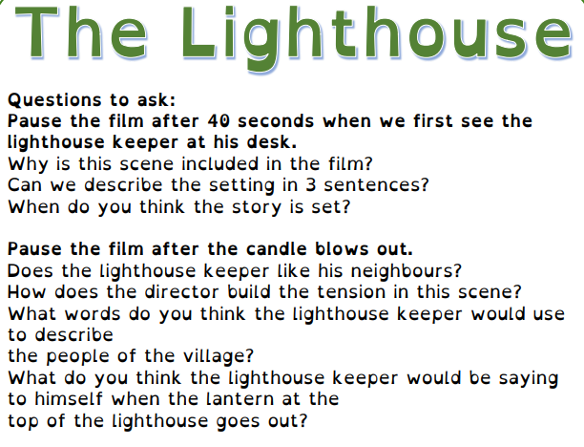
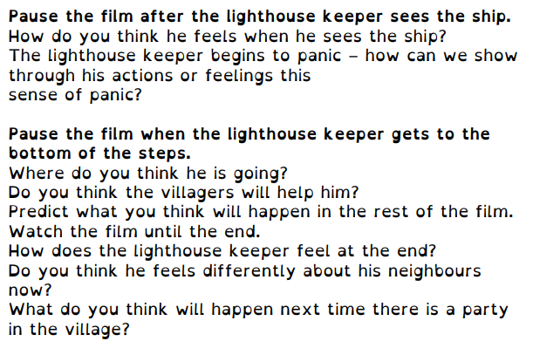
Activity 2:
How observant are you?
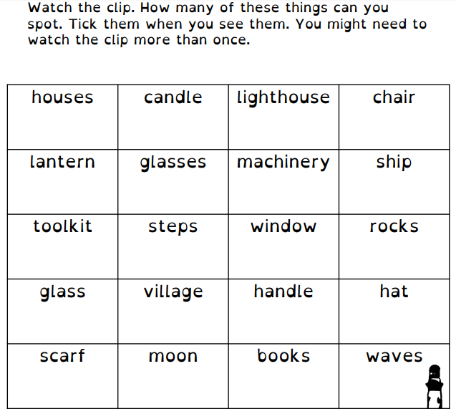

Activity 3
Lighthouse Wordsearch.
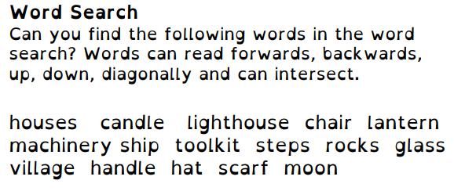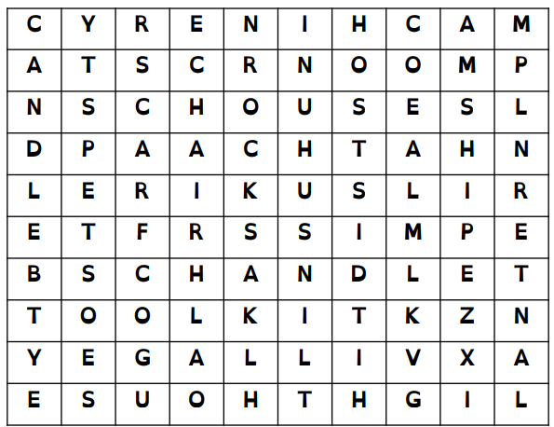

Activity 4
Why do you think this is called a diamante poem?

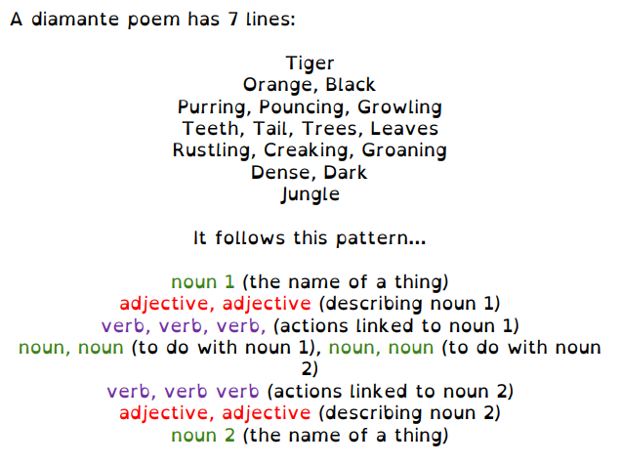

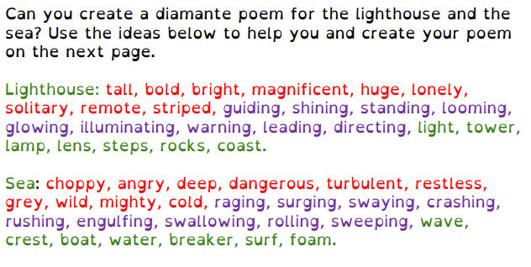
Activity 4 continued

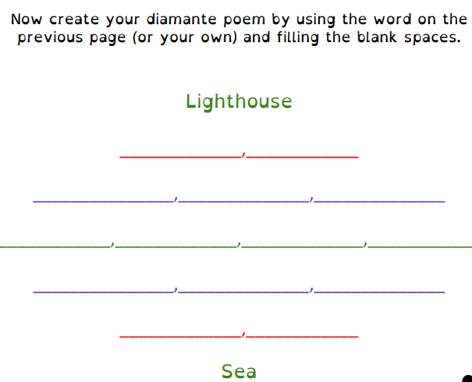

Activity 5
Read the text and answer the comprehension questions about The Lighthouse. Remember to write your answers in full sentences.
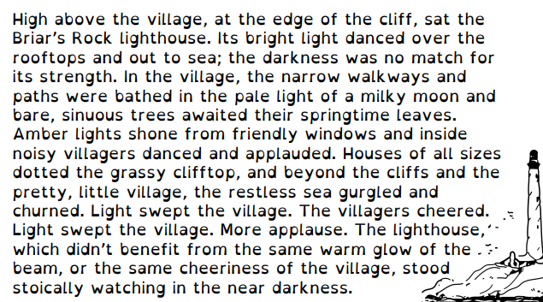

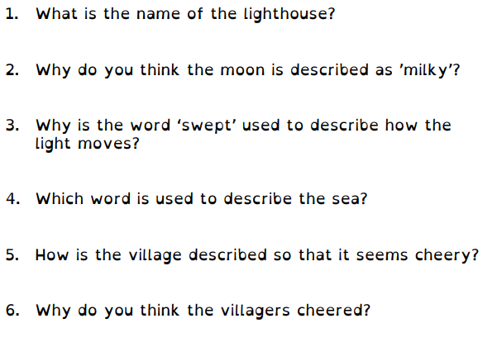

Activity 6
Write the ending of the story:
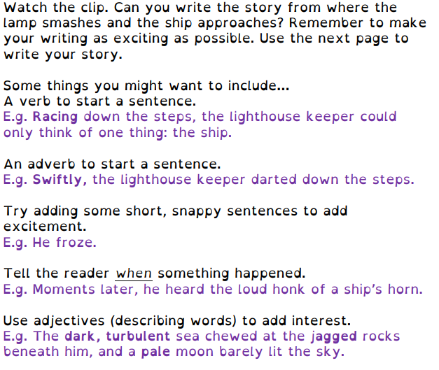
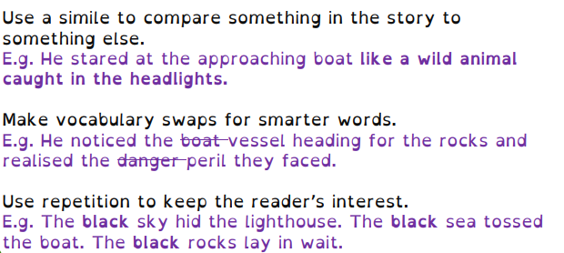

Activity 7
There is no dialogue in the film. Imagine what the characters are saying to one another and write a script for the film. You can make up names for the characters you decide to include. You can set it out like this and, if you like, include stage directions (explaining what the character is doing as they speak) in brackets.
Lighthouse keeper (bursting through the door): Help! Someone needs to help me! There’s a ship about to crash onto the rocks!
Tom (standing on a chair): Come on everyone, we need to help. Grab your lanterns!

Activity 8
Write a newspaper report about the events. You will need to include:
- A headline
- A picture with a caption
- A paragraph which explains what happened, when it happened, where it happened, who was involved, why it might have happened.
- Comments from some of the people who were involved or who were watching.
There are 2 PDF’s attached to help you with this:
- Newspaper report planning sheet
- Features of a newspaper report

Activity 9
Watch the film clip about Grace Darling. https://www.youtube.com/watch?v=Yv3eS40j0N0
MAKE SURE YOU HAVE A GROWNUP WITH YOU WHEN YOU GO ONLINE
Use the storyboard (PDF activity 9) to help you to write a diary entry about the rescue, imagining that you are Grace. You need to write in the first person and to include as much descriptive language and detail as you can. Remember to proof read your work to check you have used capital letters and punctuation accurately.

Activity 10
If you enjoyed writing the newspaper report, you could write another one about Grace Darling’s rescue.

Activity 11
Both these stories concern water safety. Think about ways people need to keep safe around water and design and make a poster to explain. The Staying Safe around Water powerpoint (attached) could give you some ideas.

